System Specification for

Adventures of an Adventurer

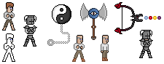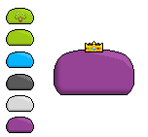

|  |  |
| --- | --- |
| Project Name | The Adventures of an Adventurer |
| Project Manager | Sascha Bertleff |
| Document Owner | Group Ferstel, Schmidt, Bertleff |
| Created on | 22.12.15 |
| Last modified | 22 December 2015, 08:14:00 |
| State | X in Work  vorgelegt  Released |
| Dokumentablage | Group Ferstl, Schmidt, Bertleff System Specifications |

**Document History**

|  |  |  |  |  |  |
| --- | --- | --- | --- | --- | --- |
| Nr. | Date | Version | Chapter | Modification | Author |
| 1 | 22.12.15 | 0.1 | 1 | Creation of the Document | Sascha Bertleff |
| 2 | 19.01.16 | 0.2 | 1-3 | Creation and modification of chapter 1 to 3 | Sascha Bertleff |
| 3 | 26.01.16 | 0.3 | 1,2,3,4 | Extending of chapter 2,3 and 4 | Sascha,  Cedric,  Oguz |
| 4 | 02.02.16 | 0.4 | 1,2,3,4 | Finished Chapter 1 to 4 | Sascha,  Cedric,  Oguz |
| 5 | 18.10.2016 | 0.4.1 | 2 | Created GUI Section of Chapter 2 | Cedric, Sascha |
| 6 | 21.10.16 | 0.4.2 | 2 | Edited GUI Section of Chapter 2 | Sascha |
| 7 | 25.10.16 | 0.4.3 | 2 | Edited GUI and OP Section of Chapter 2 | Sascha, Cedric |
| 8 | 28.10.16 | 0.5 | 6 | Created and edited Acceptance Criteria | Cedric,  Sascha |
| 9 | 29.11.16 | 0.5.1 | 6 | Created and edited Acceptance Criteria | Sascha |
| 10 | 06.12.16 | 0.5.1 | 6 | Edited Acceptance Criteria | Cedric, Sascha |
| 11 | 13.01.17 | 0.5.2 | 6 | Edited Acceptance Criteria | Sascha, Steffi |
| 12 | 17.01.17 | 0.6 | 2,6 | Added some Use Case Descriptions | Sascha |
| 13 | 22.01.17 | 0.6.1 | 2 | Added new Use Case Descriptions | Sascha |

Inhaltsverzeichnis

1. Initial Situation and Goal 2

1.1 Initial Situation 2

1.1.1 Application Domain 2

1.1.2 Glossary 2

1.2 Goal Definition 2

2. Functional Requirements 2

2.1 Use Case Diagrams 2

2.2 Explanation of the Use Cases 2

• Use Case: Game ID: 1 2

• Use Case: Fighting ID: 1.1 2

• Use Case: Fight Enemies ID: 1.1.1 2

• Use Case: Hit ID: 1.1.2 2

• Use Case: Dodge ID: 1.1.3 2

• Use Case: Shot with Bow and Arrow ID: 1.1.4 2

• Use Case: Dialogue ID: 1.2 2

• Use Case: Store Items ID: 1.2.1 2

• Use Case: Funny Dialogs ID: 1.2.2 2

• Use Case: Trade ID: 1.2.3 2

• Use Case: Get Quest ID: 1.2.4 2

• Use Case: Get Money/items ID: 1.2.3.1, 1.2.3.1.1, 1.3.1.1 2

• Use Case: Exploring ID: 1.3 2

• Use Case: Find new Places 2

• Use Case: Find Treasures ID: 1.3.1 2

2.2.2 GUI of the Game 2

2.3 Open Points 2

3. Non-functional Requirements 2

4. Quantity Structure (Schätzung Größe) 2

5. System Architecture and Interfaces 2

6. Acceptance Criteria 2

# 1. Initial Situation and Goal

The main goal of our project is to create a game that people can enjoy and find funny. This happens with the humorous story or with many innuendos and game elements which are so random that they are amusing.

We want to keep the game simple. This affects both the graphics and the gameplay. The graphics are not too big so they look pixelated and are displayable on every standard computer nowadays. The gameplay of our game should also be simplistic, only three classes (Fighter, Mage and Rouge) and a level system which is very straight forward.

The art style of the game can be compared to an old SNES game.

The compatibility with other systems will not be a problem because the Unity-Engine runs on nearly every common operating system (for example: Windows, Mac, and Linux). We also plan to release the game for Wii U later on.

## 1.1 Initial Situation

The game is made so that everyone can enjoy it. According to the game it will run on the most PC’s on Windows XP and above. After Windows the game would be playable at any Linux and MAC system. Our later goal would be to bring our game to the mobile market and develop it for Android and IOS and also for Wii U.

### 1.1.2 Glossary

* **SNES**: Super Nintendo Entertainment System; a gaming console made by Nintendo in 1990
* **Wii U**: a gaming console made by Nintendo from 2012
* **Quest**: a task given to the player by another person, mostly to receive a reward in exchange; a journey towards a goal
* **Item**: an object that in most cases has a certain usage
* **DLC:** Download Content; exclusive downloadable extra content for the game
* **Pixel Art:** pictures or graphics that are drawn using only a short amount of pixels, like for example 16x16
* **Steam:** an Internet-based digital distribution platform developed by Valve Corporation
* **Indie Games:** video games created by individuals or small teams generally without video game publisher financial support
* **Unity:** a multiple-platform game engine and development toolkit
* **RPG:** Role-Playing Game, a game genre
* **Cut Scene:** Non-playable Scene which reveals more about the Story or is just a funny sequence.
* **Open-World:** The term “open world” often describes, that the player is free to explore the world of the game.
* **NPC:** (Non-playable-Character) A person which exists to inform the player about something or which the player just can chat with.

## 1.2 Goal Definition

Our game does not aim to stun people in terms of graphical revolution or complex story telling. However we try to make our game enjoyable for everyone so there are a many ways to solve a problem. For example: One quest revolves around getting an artefact from a noble person. To get this artefact, the player has the opportunity to break into the house. One can also try to cast a hypnosis spell on the guards of the noble person, persuade them or bribe them. A more aggressive player can also decide to fight one’s way to the artefact.

# 2. Functional Requirements

## 2.1 Use Case Diagrams

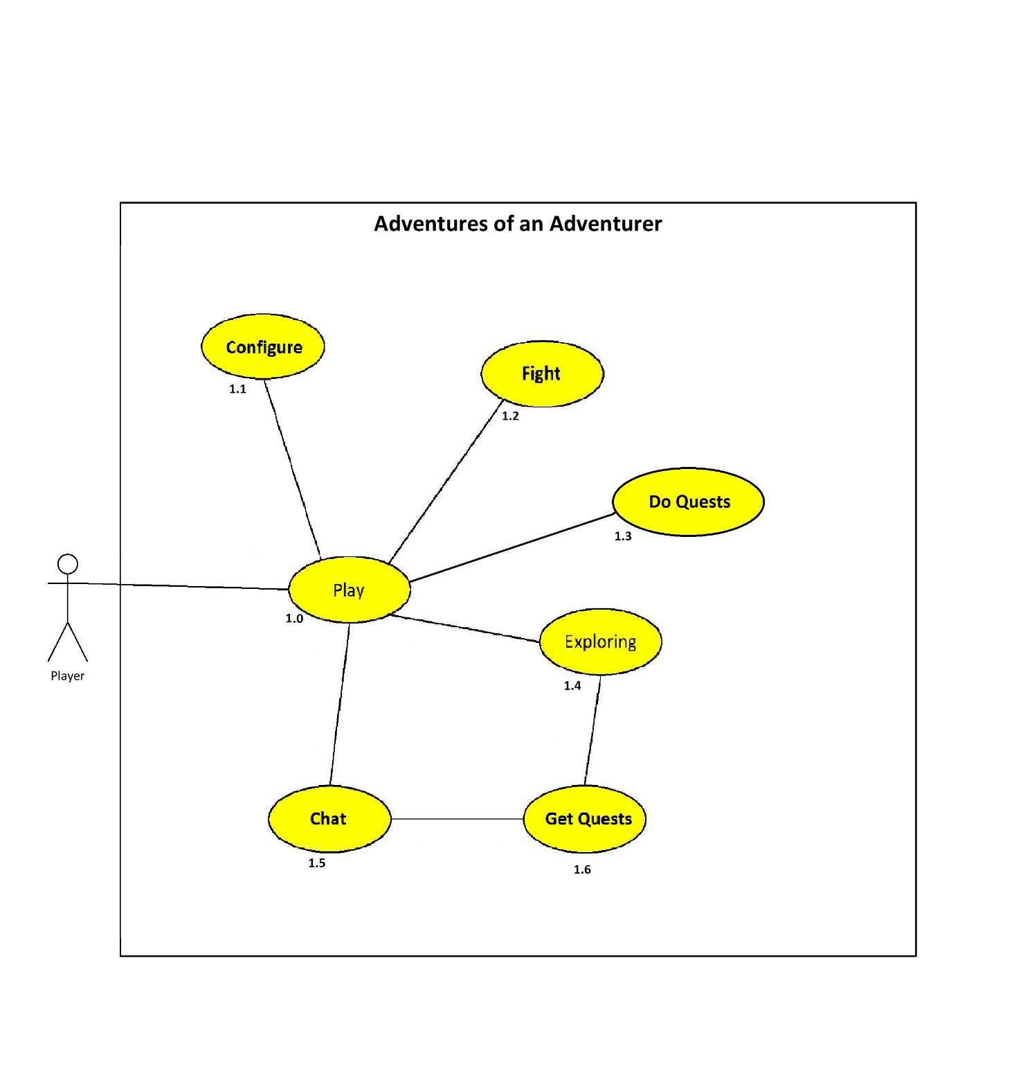

## 2.2 Explanation of the Use Cases

### Use Case: Play ID: 1.0

The basic Idea of the game is that the player can play the game. While he is doing this he can chat with NPCs, explore the environment or dungeons, or simply do quests to progress in the story. The main goal differs per player. One might only play the game to get to the higher level, while others only want to explore the story. Both is possible.

### Use Case: Configure ID: 1.1

In order to provide the best experience for the player while one plays the game, one can choose several different options. These options are: the screen resolution, the graphic details and change the volume to a level which is comfortable for the player.

### Use Case: Fight ID: 1.2

One of the main elements of the game is the fighting system. When one encounters enemies the player has to fight and defeat them. The player can choose between a variety of weapons to achieve this task. These weapons both contain melee and range weapons but also spells.

### Use Case: Do Quests ID: 1.3

In order to progress in the game one has to gain experience points to do so the player has several options, one of them is to do quests. Quests can be something simple like collecting herbs for an alchemist or something more complex like an investigation for a missing person. Quests are also divided in main quests and side quests. When the player does main quests one progresses in the story and can therefore finish the game. When completing a side quest the player can earn additional experience points and gold.

### Use Case: Exploring ID: 1.4

A main aspect of our game is the open world environment. The player is free to explore the environment and discover new things along the way. These things can be, for example, a new item or a cave which can be explored.

### Use Case: Chat ID: 1.5

The use case “chat” describes that the player can talk to every NPC in the game. While talking to an NPC it can also happen, that the player can get a new quest or just an important information. Of course not every person has to say something useful – Conclusion: there are many dialogues which just aim to entertain the player.

### Use Case: Get Quests ID: 1.6

A player can acquire quests by talking to a NPC (e.g.: a mage which lost his apprentice and the player has the quest to find him) or by just roaming the world (e.g.: an old lady which has wrenched her leg shouts for help)

## 2.2.2 GUI of the Game

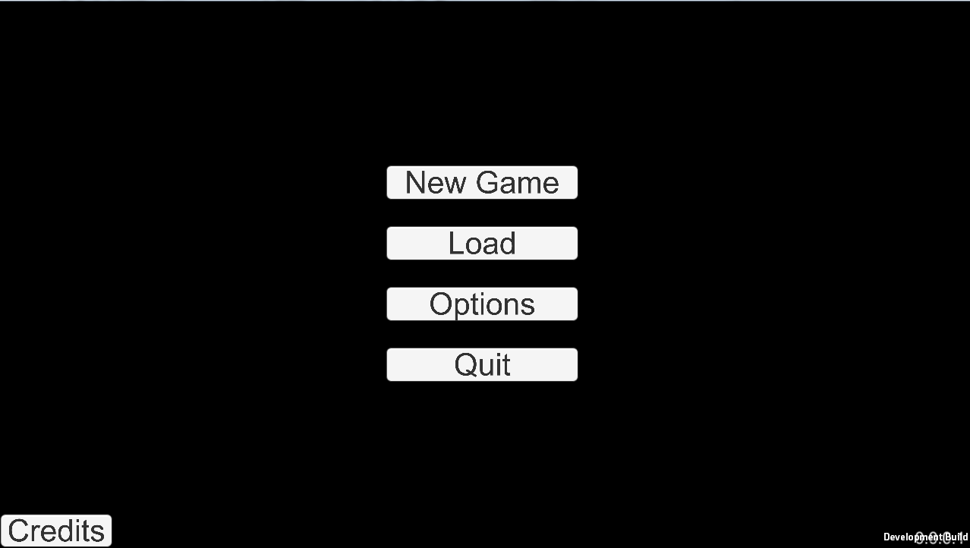Note, that all GUI elements are part of an early development build and may be changed in later versions of the game (in terms of design or structure)

Load: This button can be used, to load an existing game. (There will be 3 game slots (which are used to save the progress) which can be overwritten, if the player wants to save different game advancements)

Quit: Closes the game

Options: Some options for the game. E.g.: Audio, Language and Difficulty

New Game: With this button, the player can start a new game.

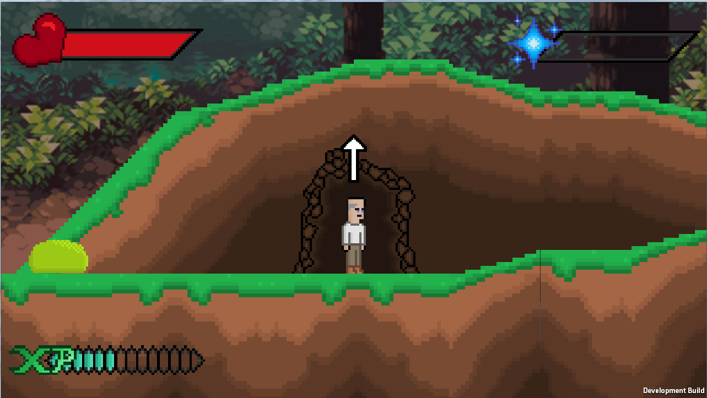

Health bar: This shows how healthy the player is. Stronger enemies will drain more health. Health can be restored by drinking Potions.

Mana bar: This shows the Mana of the player. Mana is used for spells. How much Mana is drained depends on the spell. Mana can be restored by drinking a potion.

XP bar: The XP bar shows how much Experience the player has gained. XP can be earned by slaying monsters and completing quests. How much XP are earned depends on the strength of the monster or difficulty of the quest. Every time this bar is full a new level is gained, which makes the player stronger. If no XP are gained the experience bar won’t be shown.

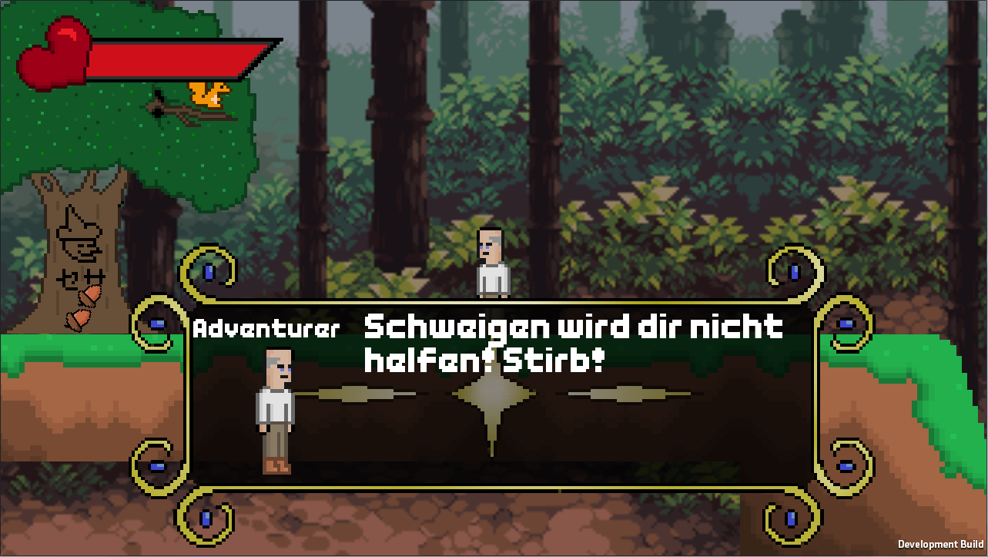

Text field: The text field appears, when someone is talking. It shows the name of the one who is speaking and a picture of him or her. It also shows the text of the conversation.

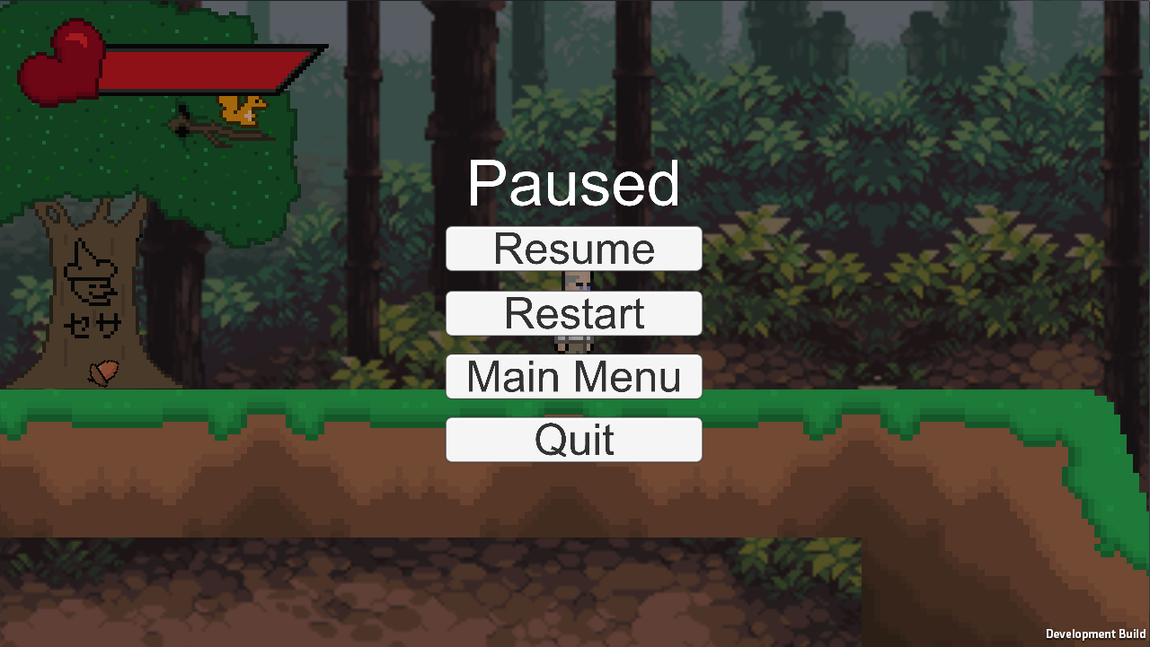

Pause Menu: This is the pause menu, which pauses the game. This screen can be shown if the player presses Esc. In this menu the player can resume, restart, go to the main menu or quit the game.

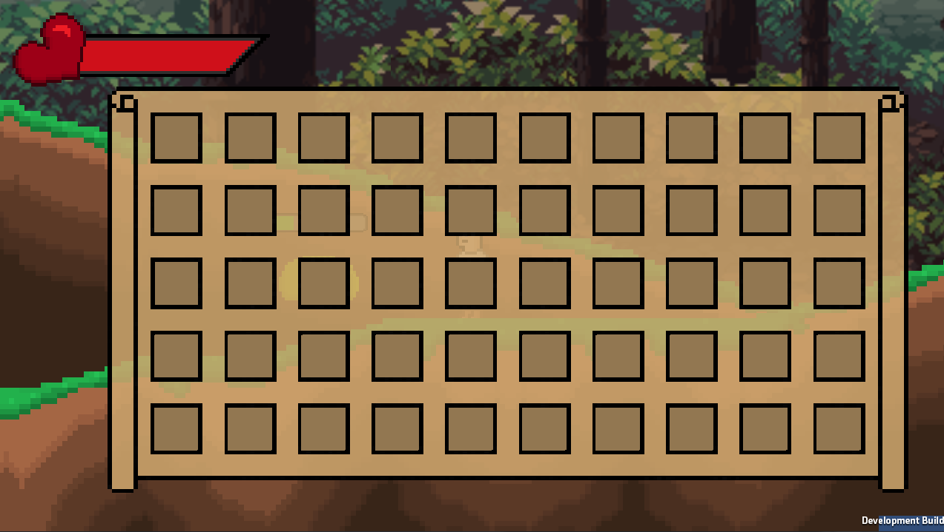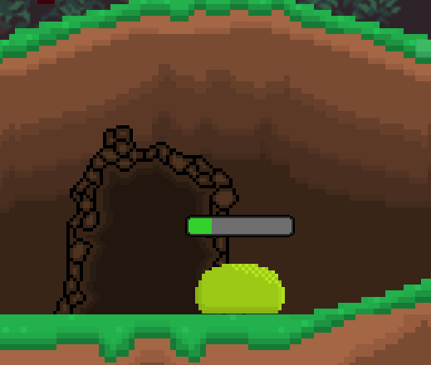

Inventory: This is the inventory of the player. It can be shown by pressing TAB. The Inventory contains the items, the player has with him.

Slot: One slot can contain one Item type. For example: one specific sword, one specific piece of armor, or several pieces of healing potions.

This is the health of the enemy, it is shown when the player firstly hits the enemy. It drains with every hit the player makes.

## 2.3 Open Points

* **Minigames?**

We haven’t decided yet if we want to implement some minigames to mix the gameplay a little bit up. There also has to be decided which minigames we want to implement, how they will look like etc.

* **Difficulty?**

It isn’t entirely clear how difficult the game will be. It mainly focuses to be entertaining for everyone so a good balanced difficulty is important.

* **Self-made Soundtrack or open source Soundtrack?**

We do not know yet if we will include our own soundtracks or if we will use some open source ones from the internet.

# 3. Non-functional Requirements

* USE:
  + easy to understand controls
  + game should be playable in German and in English
  + a not too complex story so players of every age understand the plot and storyline
  + clear and uncomplicated dialogues (in other words, a not too complex writing style like it existed in the middle age time)
* EFFIC:
  + fast runtime for smooth gameplay
  + short loading times, so the player does not have to wait a long time to continue in the story or play
  + low memory usage through use of pixel art, since these graphics do not use as much memory as for example 3D ones
* MAINT:
  + through scheduled updates bugs get fixed and new content gets released
  + users can inform Thunderclown Studios about bugs with a contact formular
* SEC:
  + encryption for the data in the save files so the users cannot simply change the location of the check point to one further in the story
  + source code won’t be included in the user version
  + source code could be offered separately for modders for example, so they could create additional content such as an item etc.
* LEGAL:
  + age requirement will eventually be defined by the uploading site itself
  + other than that there are no law requirements

# 4. Quantity Structure

The one of the most important steps on our project is, to guarantee a smooth run of the game and the low use of memory. In the following tests one will get a brief overview of the game architecture and the specs it needs. Since this is a simple game it will not need any databases and the saves will be saved into a .txt file and will be reading at any loading process. Also the configurable settings of the game will be saved into a .txt file and can be changed at any time.

# 5. System Architecture and Interfaces

This game is made with Unity 5.3 and usual for indie/pixel games it doesn’t need any high end PC to run this game smoothly.

The game can be played smoothly on every PC that does not have a lesser Windows version of Windows Vista. It can also run on many MacOS Systems or Linux Systems.

Here are the specs:

|  |  |
| --- | --- |
| OS | Windows XP and above, any IOS System which supports Unity, any Linux System which supports Unity |
| CPU | Any CPU which can run Unity 5.3 or above |
| RAM | 1 GB Ram |
| Graphic card | Any Graphic Card which can run Unity 5.3 or above |
| DirectX | DirectX 9 or above |
| Sound | DirectX compatible Soundcards |

# 

# 6. Acceptance Criteria

One of the main selling points of our game is the unique humour.

**Level 0 (Tutorial):**

* graphics for “Stoney” (a MPC that the user encounters), landscape
* functioning controls
* working collider
* squirrel who “throws” acorns as boss fight

**Level 1 (Beginning):**

* Landscape finished
* Conversation and Backstory for Adventurer finished
* Witch (old Lady) finished
* First few scenes finished before the encounter with the witch
* Pig as ridable mount
* Pig potion, tea, “groceries” and gold magnet finished.
* Gold Magnet Animation for player

**Level 2 (the city):**

* Guards finished
* NPC’s who live in the city finished
* City gate along with some houses finished
* Item shops, inn and alchemist along with the mechanics finished
* Working “White Board” with some Quests
* After some Quests working “Dully Cully” and “Deafy Greefy” Quest

**Level 3 (Slay the dragon and betray the king):**

* Working “Lavania”-District (District where the rich people live and where the player can only pass, when he has a Quest from a rich person or the king. After a while this district will also be passable if the adventurer is famous enough)
* King + Castel(outside) and Audience room finished
* Dialogue between King and Adventurer finished
* Dragon with attack movement finished
* “Dully Cully” and “Deafy Greefy” finished along with some family members
* Items which are given to the adventurer by “Dully Cully” and “Deafy Greefy” working
* Working Dragon Fight + End of Dragon fight Cut scene
* Level where the player travels to the dragon filled with enemies, items and maybe some dungeons and quests.
* End Cut scene for the fight against the dragon
* Cut Scene when the player returns to the king.